Page 1 — VPC Network Resources & EC2 SSH Connection
Topic: VPC, subnets, Internet Gateway, route tables, EC2 instance and SSH access
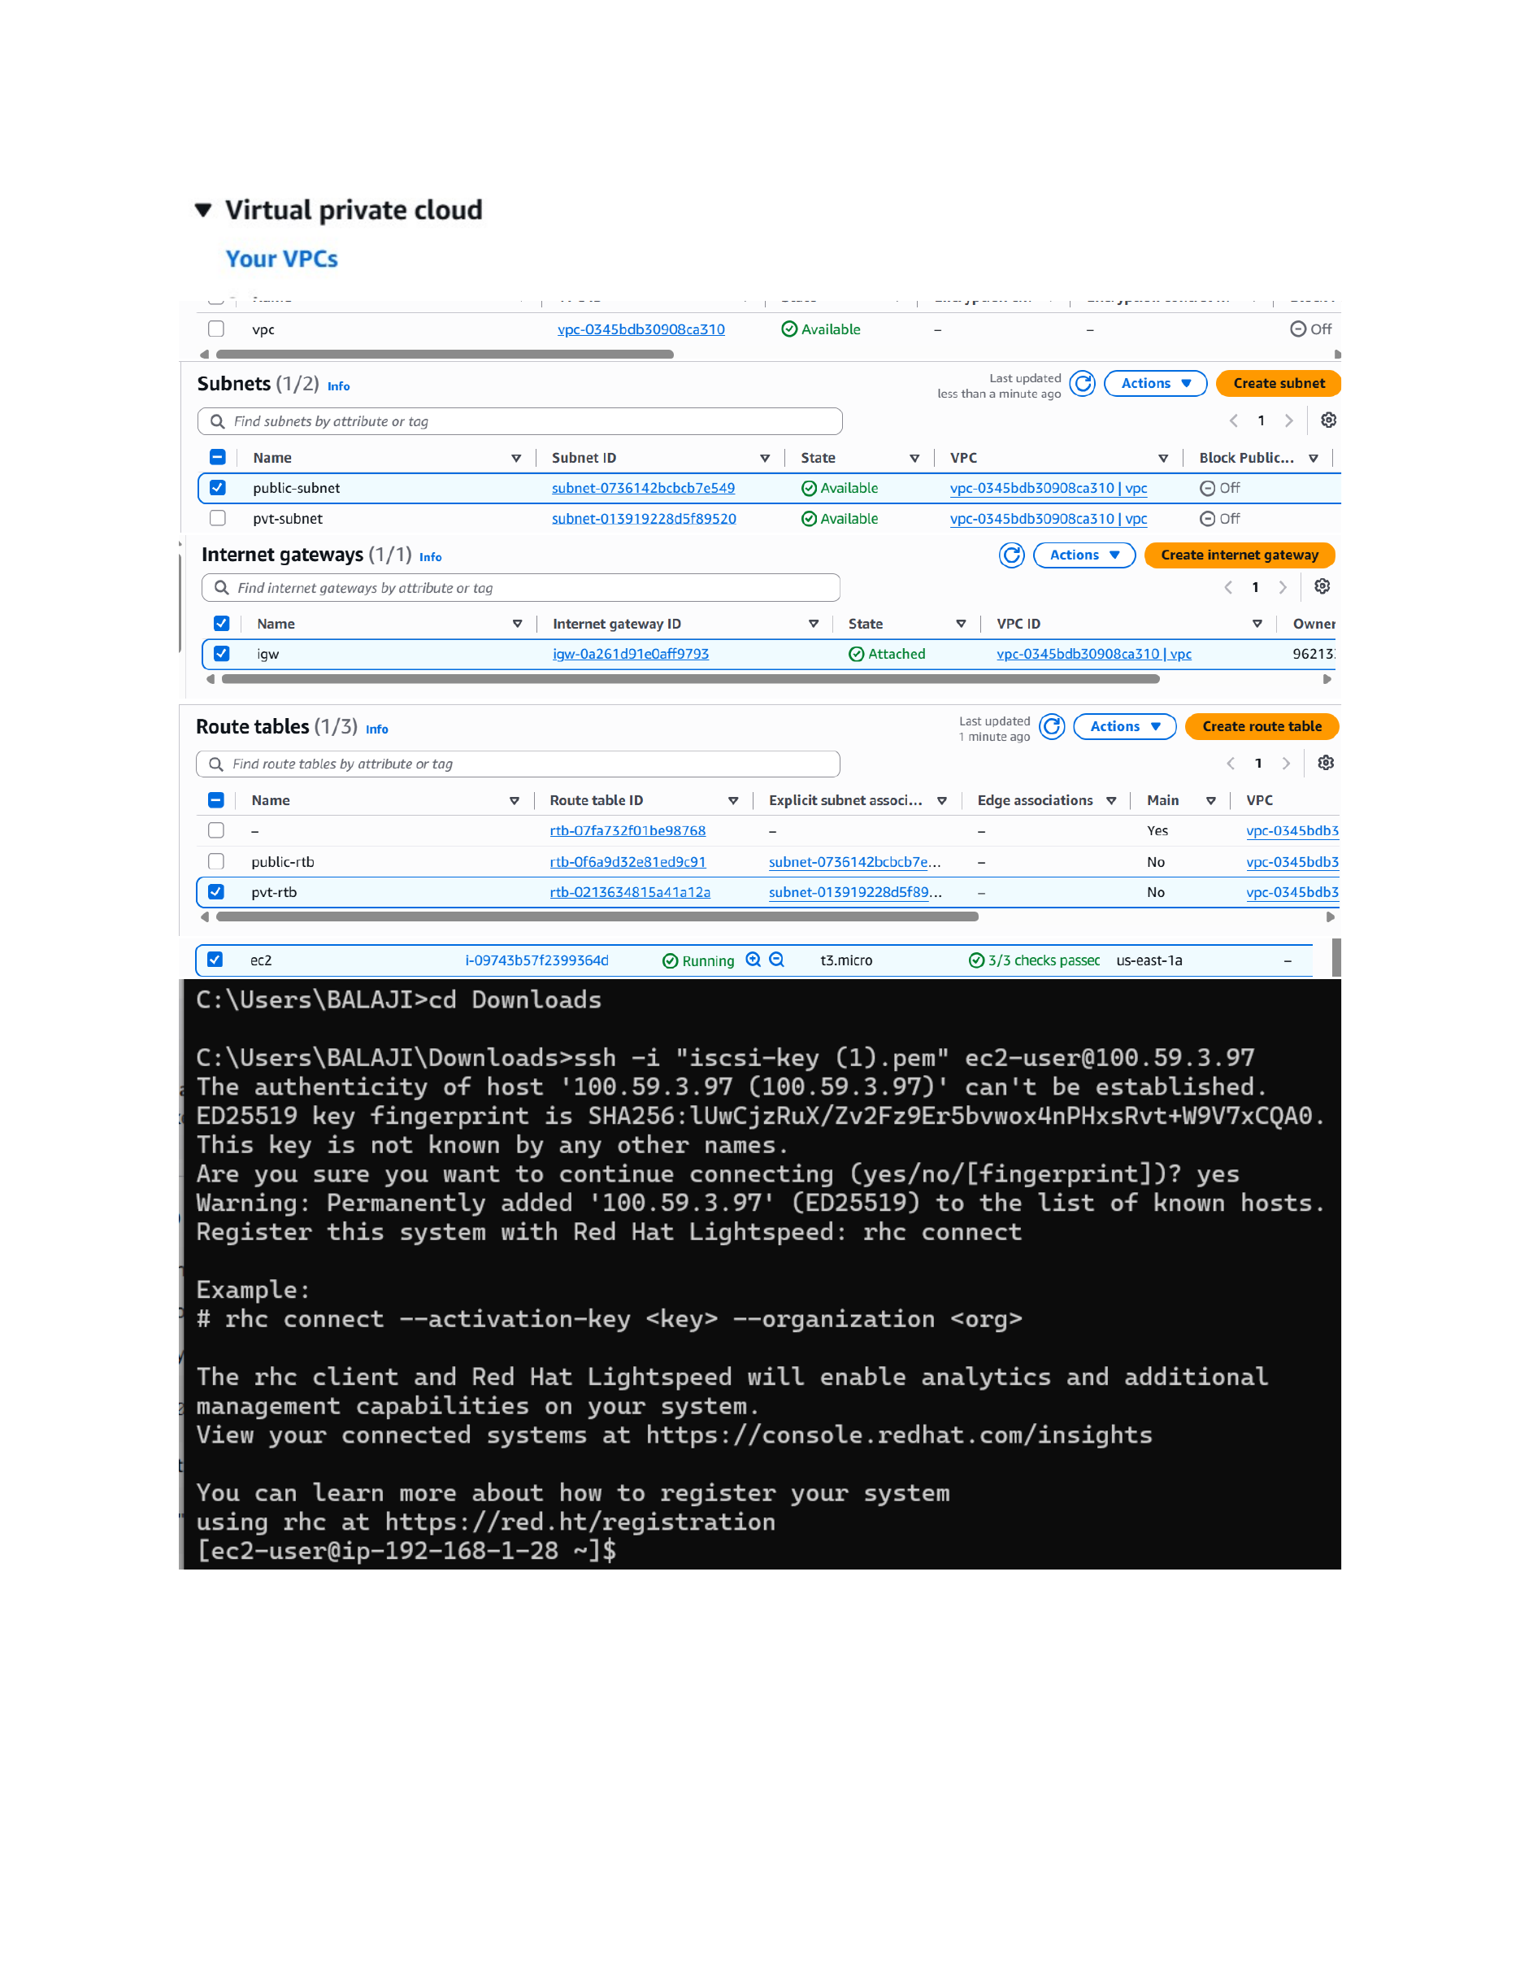
Actual action: The AWS VPC console shows the VPC with public-subnet and pvt-subnet, the attached Internet Gateway, public-rtb and pvt-rtb route tables, and the running t3.micro EC2 instance. The terminal then connects to the EC2 instance using SSH with the iscsi-key (1).pem key and reaches the ec2-user shell.

Page 2 — Install and Start Apache HTTP Server
Topic: Apache (httpd) installation and service management
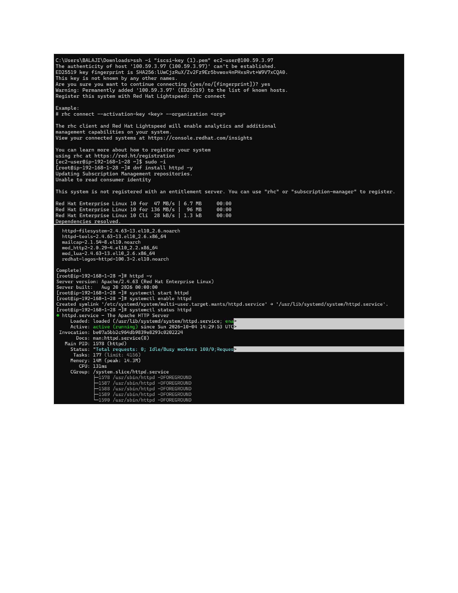
Actual action: On the RHEL EC2 instance, dnf installs httpd and its dependencies. After installation, httpd -v confirms Apache 2.4.63, then systemctl start httpd, systemctl enable httpd, and systemctl status httpd are run to start, enable, and verify the Apache service as active (running).

Page 3 — Install firewalld
Topic: Linux firewall package installation
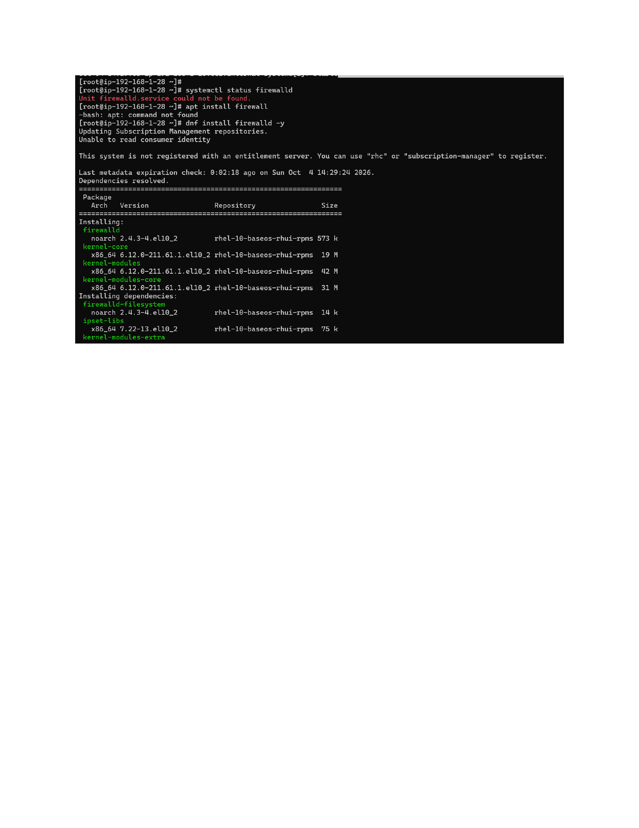
Actual action: The initial firewalld status check reports that the service is not found and the apt command is unavailable. The command dnf install firewalld -y is then used, and the firewalld package and its dependencies begin installing from the RHEL repositories.

Page 4 — Enable firewalld and Allow HTTP
Topic: Firewall service and HTTP port configuration
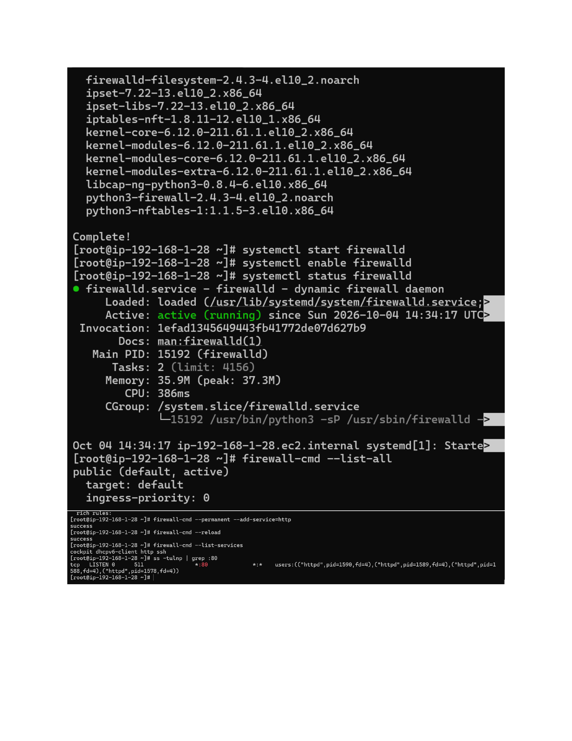
Actual action: firewalld installation is completed, then systemctl start firewalld, systemctl enable firewalld, and systemctl status firewalld confirm the firewall is active and running. firewall-cmd --permanent --add-service=http adds HTTP access, firewall-cmd --reload applies the change, and ss -tulnp | grep :80 verifies that httpd is listening on port 80.

Page 5 — Configure EC2 Inbound Rules and Create index.html
Topic: Security Group HTTP/SSH access and Apache web page file
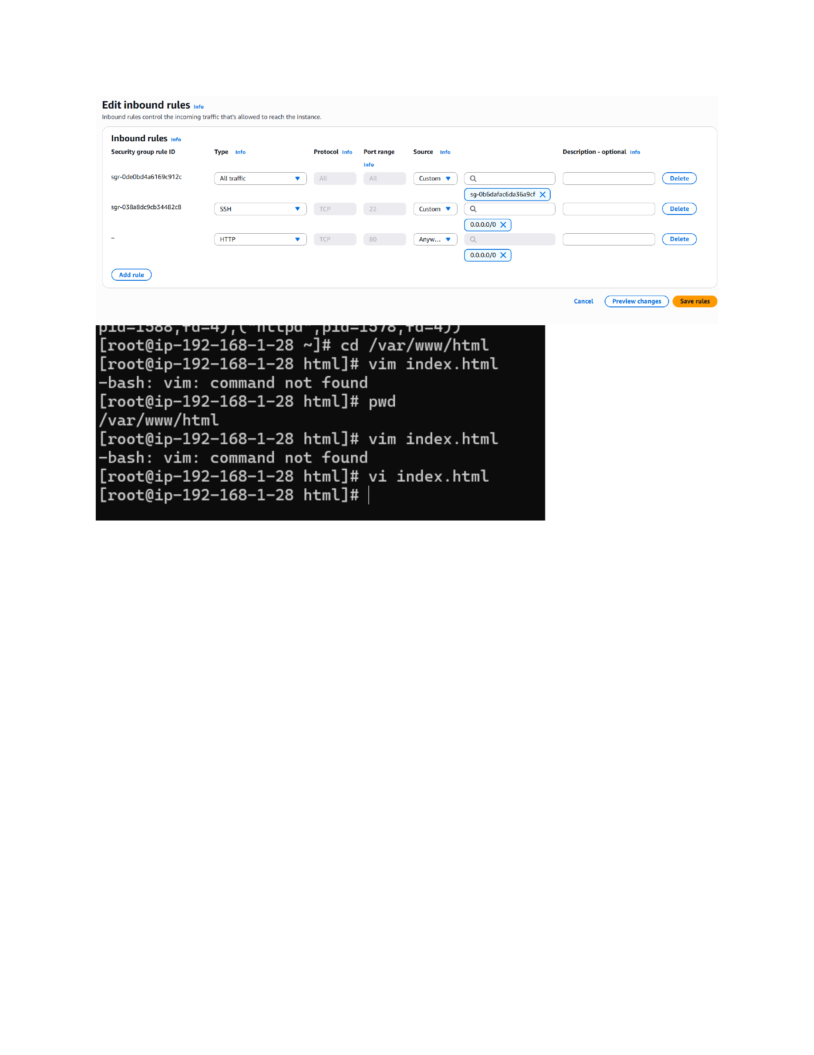
Actual action: The EC2 security group inbound rules are edited to allow SSH on port 22 and HTTP on port 80 from the shown sources. On the server, /var/www/html is opened, vim is found unavailable, and vi index.html is used instead to create/edit the website file.

Page 6 — Create and Verify the Apache Web Page
Topic: HTML page content and local web-server verification
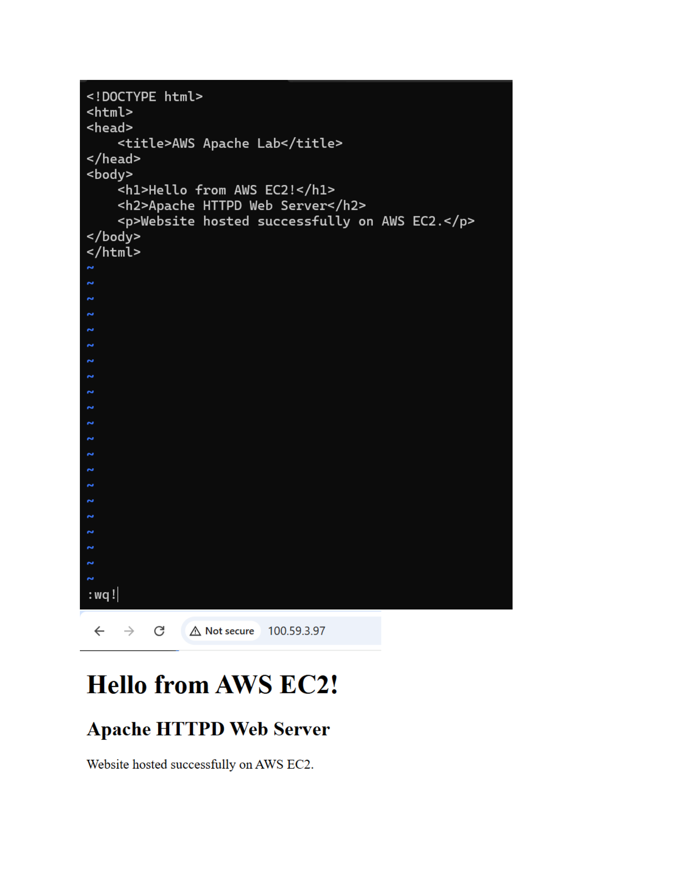
Actual action: index.html is written with the title 'AWS Apache Lab', the heading 'Hello from AWS EC2!', the subheading 'Apache HTTPD Web Server', and the text 'Website hosted successfully on AWS EC2.'. The page is then opened through the EC2 public IP and the rendered website is verified in the browser.

Page 7 — Install and Configure ngrok
Topic: ngrok installation, authentication and HTTP tunnel
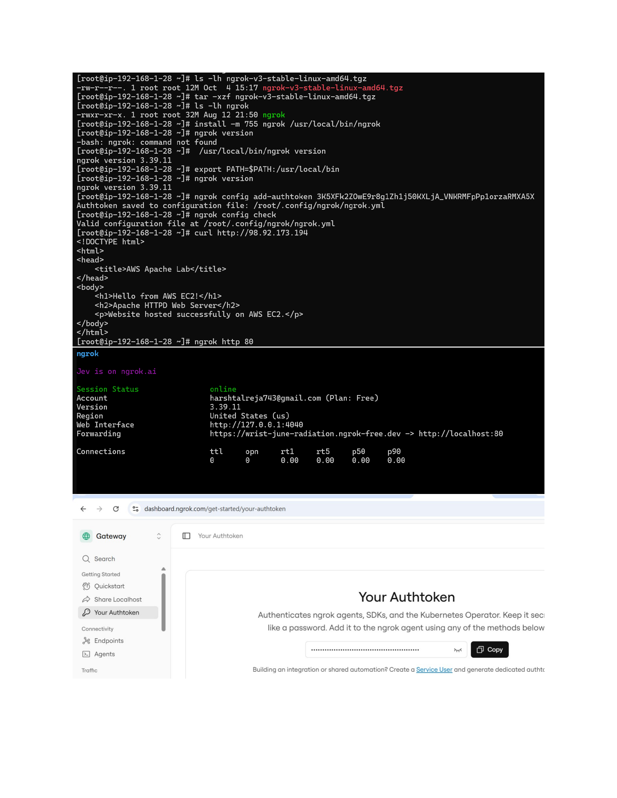
Actual action: The ngrok archive is listed and extracted, the binary is moved to /usr/local/bin, PATH is updated, and ngrok version 3.39.11 is verified. An ngrok authtoken is added and ngrok config check confirms a valid configuration. The EC2 page is tested with curl, then ngrok http 80 starts an online tunnel forwarding a public ngrok URL to localhost:80.

Page 8 — Verify the ngrok Public Website
Topic: Public HTTPS access through the ngrok tunnel
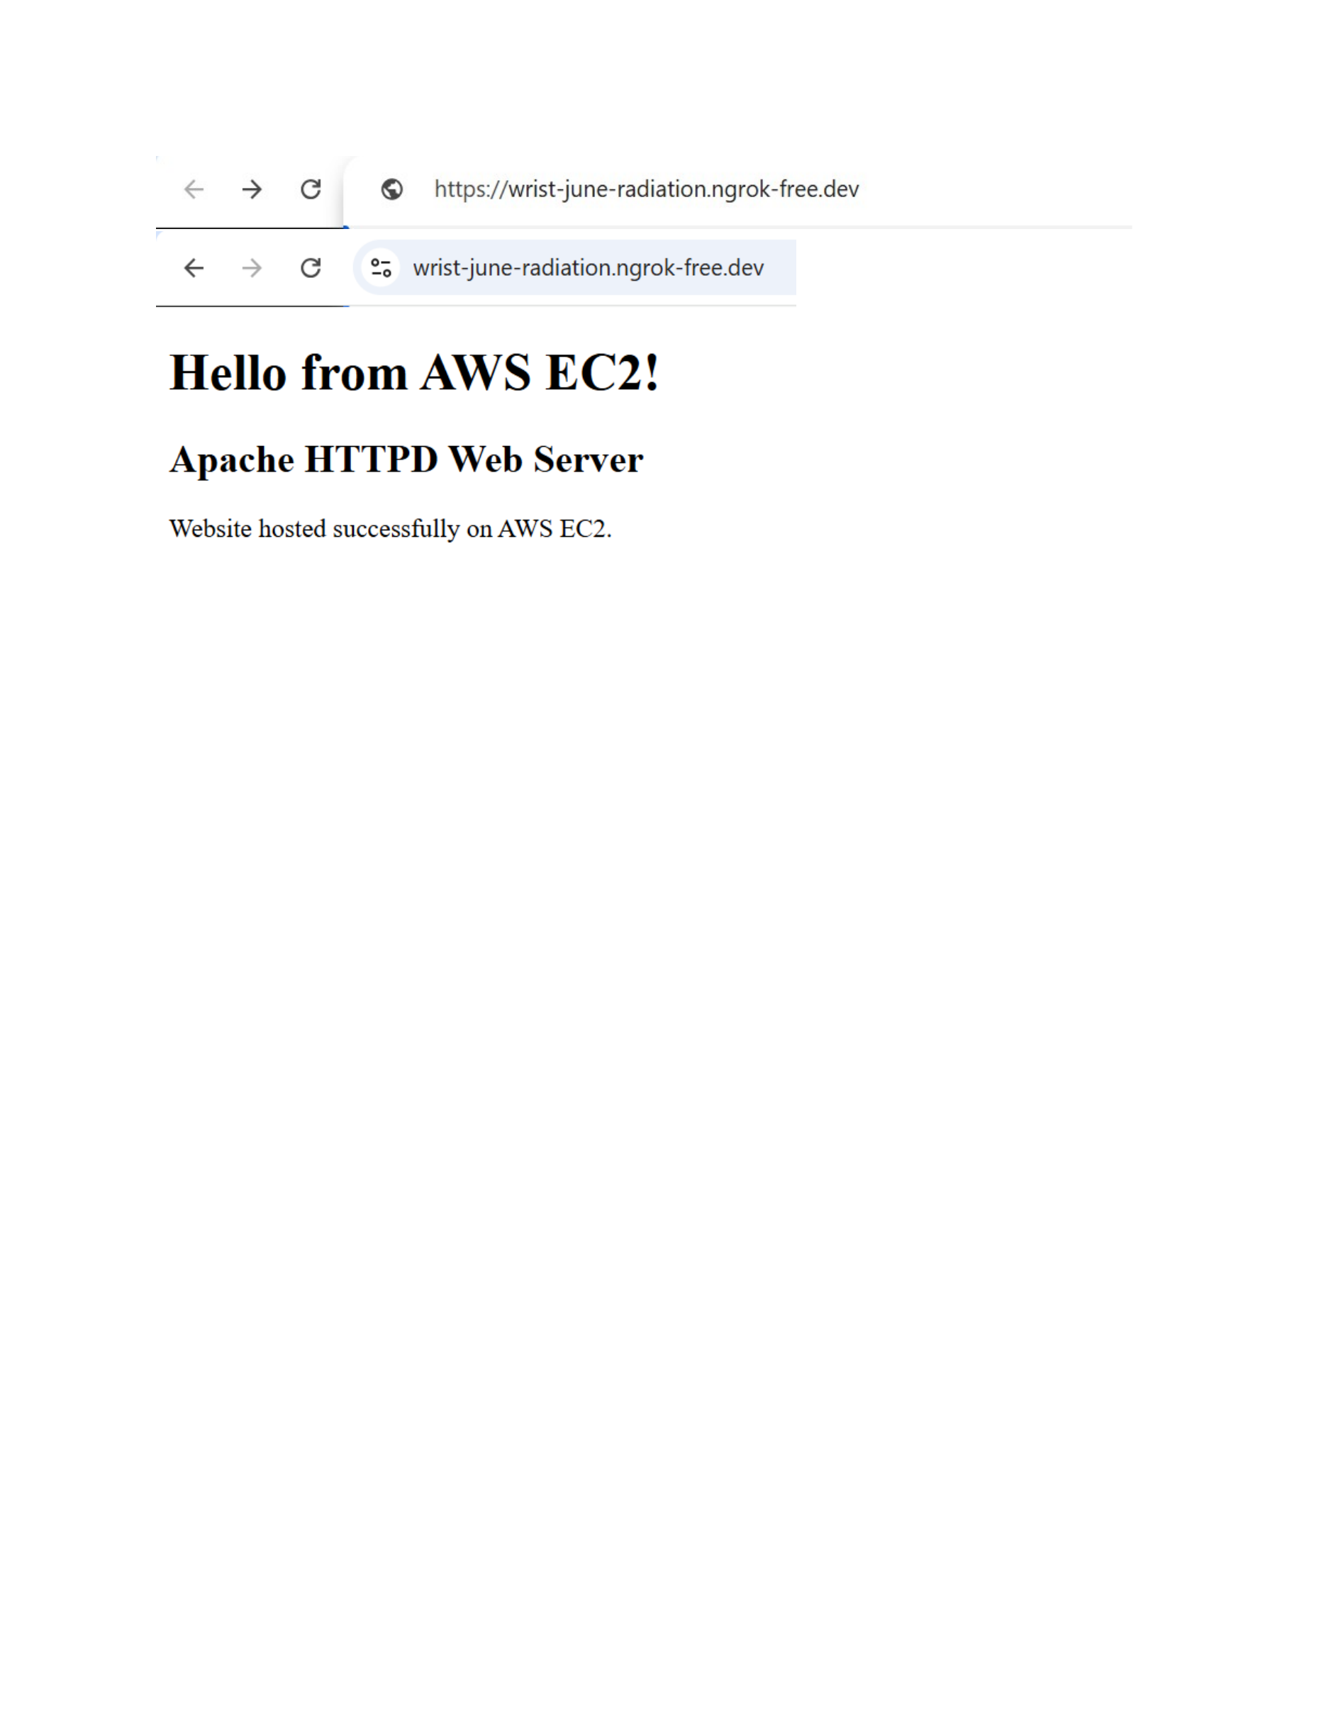
Actual action: The generated ngrok HTTPS URL is opened in the browser, and the Apache page is successfully displayed through the public tunnel with the same 'Hello from AWS EC2!' and 'Apache HTTPD Web Server' content.

